DEPARTMENT OF STATISTICS & ACTUARIAL SCIENCES
SCHOOL OF PHYSICAL & MATHEMATICAL SCIENCES
FIRST SEMESTER, 2025/2026 ACADEMIC YEAR
M.SC APPLIED STATISTICS
ASTA 607: COMPUTATIONAL STATISTICS I
ID: 22424407

Question 1
- Codes

> library(MASS)
> data(crabs)
> View(crabs)
> ### Question 1
> #a.
> ?crabs
Answer:
The crabs data frame has 200 rows and 8 columns, describing 5 morphological measurements on 50 crabs each of two colour forms and both sexes, of the species Leptograpsus variegatus collected at Fremantle, W. Australia.

- Codes

> #b.
> data(crabs)
> str(crabs)
Output
> str(crabs)
'data.frame': 200 obs. of 8 variables:
$ sp : Factor w/ 2 levels "B","O": 1 1 1 1 1 1 1 1 1 1 ...
$ sex : Factor w/ 2 levels "F","M": 2 2 2 2 2 2 2 2 2 2 ...
$ index: int 1 2 3 4 5 6 7 8 9 10 ...
$ FL : num 8.1 8.8 9.2 9.6 9.8 10.8 11.1 11.6 11.8 11.8 ...
$ RW : num 6.7 7.7 7.8 7.9 8 9 9.9 9.1 9.6 10.5 ...
$ CL : num 16.1 18.1 19 20.1 20.3 23 23.8 24.5 24.2 25.2 ...
$ CW : num 19 20.8 22.4 23.1 23 26.5 27.1 28.4 27.8 29.3 ...
$ BD : num 7 7.4 7.7 8.2 8.2 9.8 9.8 10.4 9.7 10.3 ...

Comment:
The Crabs dataset is a dataframe with 200 observations of 8 variables. The frontal lobe size (mm), rear width (mm), carapace length (mm), carapace width (mm), body depth (mm) are numeric while species - "B" or "O" for blue or orange and sex are factors each with three (3) levels. The index 1:50 within each of the four groups is an integer.

- Codes

> #c
> sfreq <- table(crabs$sp, crabs$sex)
> rownames(sfreq) <- rbind("Blue", "Orange")
> print(sfreq)
Output
F M
Blue 50 50
Orange 50 50
Comment:
The contingency table above shows the frequency for species and sex. Each species has 50 crabs and each sex has 50 crabs. This implies that the data is balanced and is reliable for subsequent group comparison(like using Chisquare)

- Codes

> #d.
> barplot(sfreq, xlab = "Sex", ylab = "Frequency", main = "Composite barchart of species by sex",
+ col = rainbow(2), legend = TRUE)

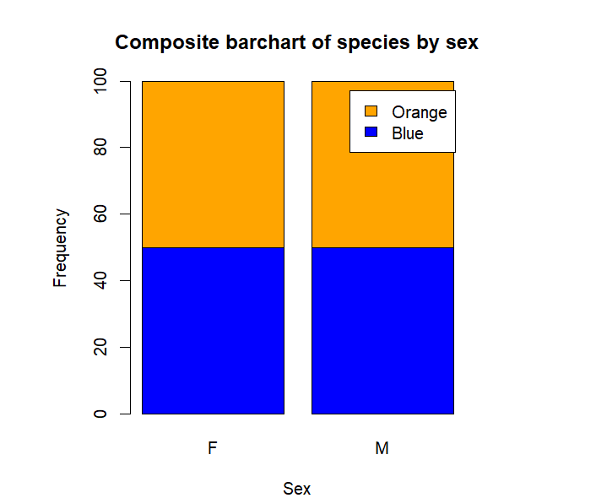
Figure 1: Composite Bar chart of Species by Sex
The bar chart in figure 1 shows the distribution of the species of crabs by sex. There are equal number of crabs for each species by their sex.

- Comment:
The dataset is balanced across the four groups implying that it is reliable for subsequent group comparison. The results from the comparisons will be statistically unbiased since they have equal sample size (50 crabs)

Question 2
- Codes

> #a.
> ?boxplot
> boxplot(BD ~ sp * sex, data = crabs,col = c("blue", "orange"),
+ main = "Side-by-Side Boxplots of Body Depth",
+ xlab = "Species and Sex",
+ ylab = "Body Depth")

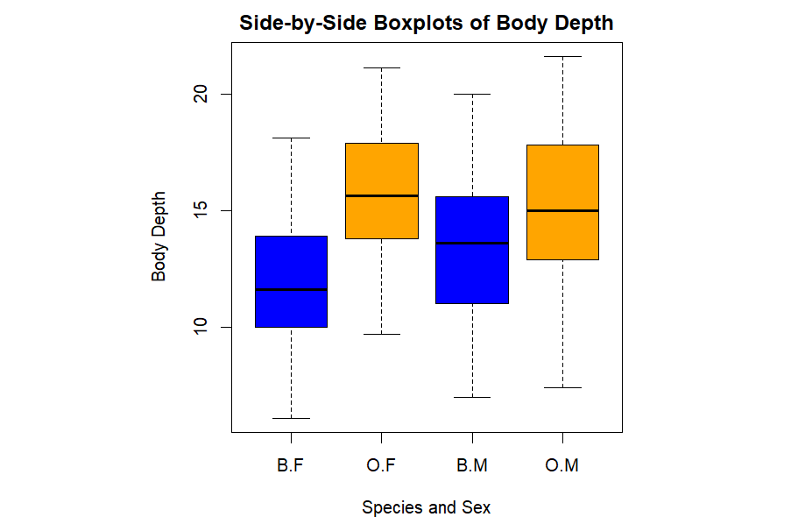
Figure 2: Boxplot of Body Depth for the four groups(Species and Sex)

The boxplot in figure 2 shows that the body depths for the four (4) groups defined by species and sex. Graphically, the median of the body depths of orange female crabs is higher than the other groups while that of blue females is the lowest. This implies that orange female crabs have higher body depths compared to the others.

- Answer:
There are no outliers. The boxplot in figure 2 shows that the body depths for the four (4) groups defined by species and sex. Graphically, the median of the body depths of orange female crabs is higher than the other groups while that of blue females is the lowest. This implies that orange female crabs have higher body depths compared to the others.

Question 3
- Codes

> par(mfrow = c(1,2), mar = c(4,4,2,1))
> hist(crabs$CL[crabs$sp == "B"], xlab = "Carapace Length (in mm)", main = "Blue", col = "blue")
> hist(crabs$CL[crabs$sp == "O"], xlab = "Carapace Length (in mm)", main = "Orange", col = "orange")
> #Describe
> tapply(crabs$CL, crabs$sp, summary)

Output
> #Describe
> tapply(crabs$CL, crabs$sp, summary)
$B
Min. 1st Qu. Median Mean 3rd Qu. Max.
14.70 24.85 30.10 30.06 34.60 47.10

$O
Min. 1st Qu. Median Mean 3rd Qu. Max.
16.70 29.20 34.55 34.15 39.40 47.60

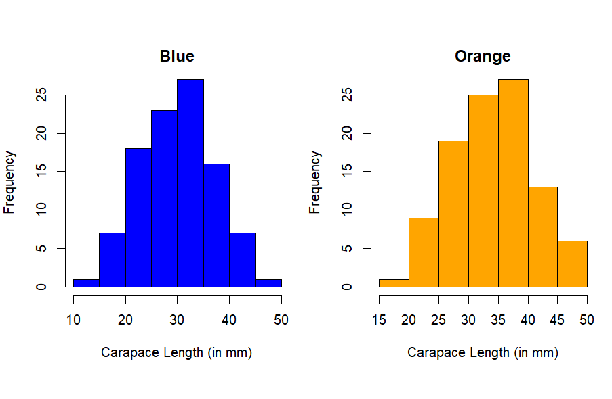
Figure 3: Histograms of Carapace Length for each species
Figure 3 shows the histogram of the Carapace length for each species (Blue and Orange). Both species are unimodal. The Carapace length for Blue species is approximately right skewes while that of Orange species is approximately left skewed. The orange species has ,on average, the highest carapace length(34.15 mm).

- Answer:
Figure 3 shows the histogram of the Carapace length for each species (Blue and Orange). Both species are unimodal. The Carapace length for Blue species is approximately right skewes while that of Orange species is approximately left skewed.

Question 4
- Codes

> ##Question 4
> #a compute the mean of FL,RW,CL,CW,BD by species and sex
> #Mean for FL
> mfl<- tapply(crabs$FL, list(crabs$sp, crabs$sex), mean)
> #Mean for RW
> mrw<- tapply(crabs$RW, list(crabs$sp, crabs$sex), mean)
> #Mean for CL
> mcl<- tapply(crabs$CL, list(crabs$sp, crabs$sex), mean)
> #Mean for CW
> mcw<- tapply(crabs$CW, list(crabs$sp, crabs$sex), mean)
> #Mean for BD
> mbd<- tapply(crabs$BD, list(crabs$sp, crabs$sex), mean)
> #Each Measurement
> par(mfrow = c(1,1), mar = c(4,4,2,1))
> Overall_mean <- rbind(
+ FL = as.vector(mfl),
+ RW = as.vector(mrw),
+ CL = as.vector(mcl),
+ CW = as.vector(mcw),
+ BD = as.vector(mbd)
+ )
print(Overall_mean)

Output
Table 1: Mean of each morphological measurement by Species and Sex
[,1] [,2] [,3] [,4]
FL 13.270 17.594 14.842 16.626
RW 12.138 14.836 11.718 12.262
CL 28.102 34.618 32.014 33.688
CW 32.624 39.036 36.810 37.188
BD 11.816 15.632 13.350 15.324
Comment:
Table 1 shows the mean of each morphological measurement (frontal lobe size (mm), rear width (mm), carapace length (mm), carapace width (mm) and body depth (mm)) by species (Blue and Orange) and sex(Male and Female).

- Codes

> par(mfrow = c(2,3), mar = c(4,4,2,1))
> barplot(mfl,beside = TRUE,col = c("blue", "orange"),legend = rownames(mfl),
+ main = "Mean FL by Species and Sex",xlab = "Sex",ylab = "Mean")
> barplot(mrw,beside = TRUE,col = c("blue", "orange"),legend = rownames(mrw),
+ main = "Mean RW by Species and Sex",xlab = "Species",ylab = "Mean")
> barplot(mcl,beside = TRUE,col = c("blue", "orange"),legend = rownames(mcl),
+ main = "Mean CL by Species and Sex",xlab = "Species",ylab = "Mean")
> barplot(mcw,beside = TRUE,col = c("blue", "orange"),legend = rownames(mcw),
+ main = "Mean CW by Species and Sex",xlab = "Species",ylab = "Mean")
> barplot(mbd,beside = TRUE,col = c("blue", "orange"),legend = rownames(mbd),
+ main = "Mean BD by Species and Sex",xlab = "Species",ylab = "Mean")

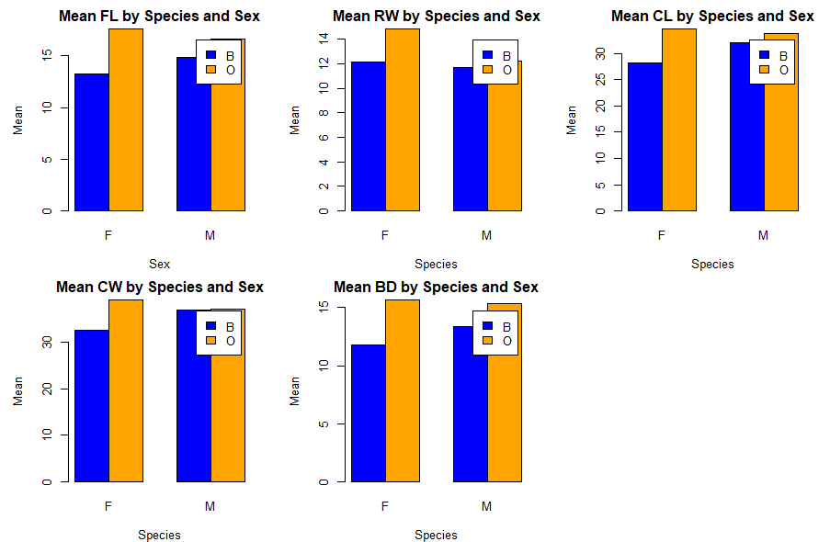

- Answer:
The greatest species difference

Question 5
- Codes

> # Produce a scatterplot matrix (pairs plot) of the five mearsurement
> # Select the five measurements
> five_measures <- crabs[, c("FL", "RW", "CL", "CW", "BD")]
> #Scatter plot for the 5
> pairs(five_measures,
+ main = "Scatterplot Matrix(pairs plot) of the 5 Crab Measurements",
+ pch = 19,
+ col = "red")
>

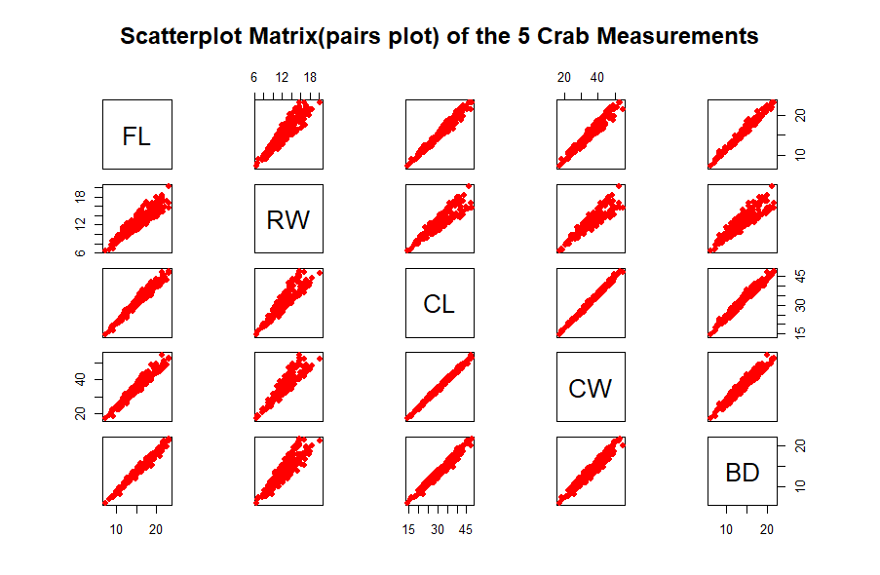

Comment:
There a strong positive relationship between the five (5) measurements

Question 6: STATISTICAL REPORT
Introduction
The crabs data frame has 200 rows and 8 columns, describing 5 morphological measurements on 50 crabs each of two color forms and both sexes, of the species Leptograpsus variegatus collected at Fremantle, W. Australia.
The Crabs dataset is a data frame with 200 observations of 8 variables. The frontal lobe size (mm), rear width (mm), carapace length (mm), carapace width (mm), body depth (mm) are numeric while species - "B" or "O" for blue or orange and sex are factors each with three (3) levels. The index 1:50 within each of the four groups is an integer. The aim is to describe the strength and nature of the relationships among the four (4) morphological measurements.
Source:
Campbell, N.A. and Mahon, R.J. (1974) A multivariate study of variation in two species of rock crab of genus Leptograpsus. Australian Journal of Zoology 22, 417–425.

Analysis
The analysis was done in R software. The results can be found below;

Descriptive Analysis
To understand the structure and composition of species and sex, a descriptive analysis for the species by the sex was done using a composite bar chart. This helps us know if the for the species by the sex is balanced for reliable results.
The bar chart in figure 1 shows that the distribution of the species of crabs by sex is balanced and reliable for subsequent comparisons. There are equal number of crabs (50) for each species by their sex.


Figure 1: Composite Bar chart of Species by Sex

The boxplot in figure 2 shows that the body depths for the four (4) groups defined by species and sex. Graphically, the median of the body depths of orange female crabs is higher than the other groups while that of blue females is the lowest. This implies that orange female crabs have higher body depths compared to the others.


Figure 2: Boxplot of Body Depth for the four groups (Species and Sex)

The distribution of the carapace length for each species tells us which species has the longest crab shell (CL).
Interpretation
Figure 3 shows the histogram of the Carapace length for each species (Blue and Orange). Both species are unimodal. The Carapace length for blue species is approximately right skewes while that of Orange species is approximately left skewed. The orange species has, on average, the highest carapace length (34.15 mm).


Figure 3: Histograms of Carapace Length for each species

Table 1 shows the mean of each morphological measurement (frontal lobe size (mm), rear width (mm), carapace length (mm), carapace width (mm) and body depth (mm)) by species (Blue and Orange) and sex(Male and Female).

Table 1: Mean of each morphological measurement by Species and Sex
[,1] [,2] [,3] [,4]
FL 13.270 17.594 14.842 16.626
RW 12.138 14.836 11.718 12.262
CL 28.102 34.618 32.014 33.688
CW 32.624 39.036 36.810 37.188
BD 11.816 15.632 13.350 15.324

Conclusion
Based on the analysis, we can conclude that there is a strong positive relationship between the 4 morphological measurements. This means that big crabs have higher frontal lobe size (mm), rear width (mm), carapace length (mm), carapace width (mm) and body depth (mm).

